PERSONAL PROFILE
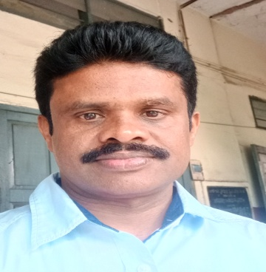
- NAME OF THE LECTURER : Dr.G.LAKSHMANA RAO
- SUBJECT : Chemistry
- ACADEMIC QUALIFICATIONS : (i) M.Sc. 60.2% (Andhra University)
(With percentages/Grades) (ii) AP SET
(iii) Ph. D (ACHARYA NAGARJUNA UNIVERSITY, GUNTUR)
- DATE OF BIRTH : 01-07-1975
- DATE OF ENTRY IN TO SERVICE : 17-06-2002
- DATE OF RETIREMENT : 30-06-2035
- SCALE OF PAY(UGC/STATE) : 15600-39100+ AGP 6000/- (UGC 2006 PAY SCALES)
- DETAILS OF PREVIOUS SERVICE : (i) Secondary Grade Teacher
(From 21-08-1998 to 16-06-2002)

(ii) JUNIOR LECTURER
(From 17-06-2002 to 21-05-2013)
- PAPER PUBLICATIONS : 1. “Theories of Ultrasonic velocities and their application in (NATIONAL/INTERNATIONAL JOURNALS) binary liquid mixtures of ethyl benzoate with 2- alkoxyethanols at different temperatures.” Der Pharma Chemica,2015,7(5):157-166
2. “Theoretical evaluation and comparative study of ultra-
sonic velocities in binary liquid mixtures of ethyl benzoate with some cresols at different temperatures.”
Journal of Chemical and Pharmaceutical Research, 2015, 7(6): 367-375.
3. “Excess parameters of binary liquid mixtures of ethyl
benzoate with o-xylene, p-xylene and o-chlorotoulene
at different temperatures.”
Journal of Chemical and Pharmaceutical Research, 2015, 7(8): 885-896.
4. “Theoretical evaluation of ultrasonic velocity in binary
mixtures of isomeric butanols with ethyl benzoate.”
Der Pharma Chemica,2015,7(10):
5. Probing the intermolecular interactions in the binary liquid mixtures of o-chlorophenol with alkoxyethanols through ultrasonic, transport and FT-IR spectroscopic studies at different temperatures.
Journal of Molecular Liquids,216(2016)526-537.

- OCs/RCs/SEMINARS/
WORKSHOPS : 1. Refresher Course at University of Hyderabad
2. Orientation Course at Andhra University
3. Paper presented on ERADICATION OF POLUTIONTHE ROLE OF SCIENCE at national seminar at VSR&NVR COLLEGE, TENALI. A.P.
4. National seminar on recent trends in separation processes in pollution control at KRR Govt. Arts and Science College, Kodad,A.P.
5. Attended national seminar on RECENT TRENDS IN CHEMISTRY at Govt Degree College, Kodur, Kadapa dist.
6. Attended as JURY PANNEL MEMBER at District level Science exhibition at BS & JR HS ,Tekkali.
7. District Level Work Shop on Indian Banking – Trends and Challenges at GDC, Tekkali.

13. Research Status : Awarded Ph.D on 09.02.2016 from ANU, Guntur.
14. Academic activities involved : I) IQAC coordinator
(CURICULAR/COCURRICULAR/EXTRA CURRICULAR) II) NAAC coordinator
III) TISS MODULE
IV) Dealing HVPE Classes

15. Co curricular Activities : I Acted as NSS Programme Officer
II) Incharge for voter enrolment of the students

16. AWARDS (IF ANY) : NO

